Balkan Olympiad in Informatics 2007  Chisinau, Moldova |  | MOLDOVA
Task: Cipher |  | Day 1

Cipher

While doing a routine exploration of the Universe, the Balkan Space Agency (BSA) guys have found traces of extraterrestrial (ET) intelligence.
More exactly, they have found a collection of rectangular metal plates containing messages written in the ET’s language. Each plate contains a 2D array with n rows and m columns, each element of the array being a printable ASCII character with the corresponding numeric code in the range 32 … 127. Also, each plate contains two more integers, which we will name a and b.
After studying the plates, the specialists of BSA have concluded that the ET's messages can be decrypted by using a cipher, e.g. a key which unveils the way to understand the message, which is hidden right into the rectangular array of that same plate.
The researchers have found out that the cipher is the rectangular subarea of the message, having the size of a rows by b columns that appears exactly k times, 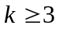. The subareas of the message which contain the cipher might overlap. It is also known that no other subarea of a rows by b columns in the metal plate can appear more than 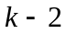 times.
For example, if the rectangular array in the plate has a size of 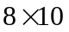, e.g. 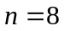 and 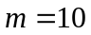, and the cipher appears 5 times on the plate (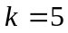), and its size is 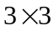 (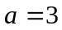, 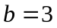), no other subarray of this array will appear more than 3 times.
You are asked to write a program that, given the rectangular array which represents the ET’s message and the integers a and b which are written on the plate, finds the cipher and the positions on the plate where it can be found.

Input. The first line of the text file cipher.in contains the integers n and m, separated by a blank character. Then n lines follow, each containing one m characters long string. The i’th line represents the i’th line of the rectangular array written on the plate. The last line of the file contains the integers a and b, separated by a blank.

Output. The first line of the text file cipher.out must contain the integers a and b, separated by a blank. These numbers should be exactly equal to the ones found in the input file. Each of the next a lines of the text should contain a b characters long string, representing the cipher you have found. The next line of the output file must contain the integer k, the number of instances of the cipher you have found in the array. Then k lines of text should follow, each containing two integers delimited by a blank. These two numbers must represent the (row, column) position of the upper-left corner of the instances of the cipher you have found in the array. You may output the pairs in any order.

Example.

cipher.in |  | cipher.out
8 10  qw.aba..f.  wq.bab.ff.  zx.cdc.K.R  c.ababa.es  x.babab.Ed  j.cdcdcaba  yo.k.k.bab  opu..l.cdc  3 3 |  | 3 3  aba  bab  cdc  4  1 4  4 3  4 5  6 8

The array and the 4 instances of the cipher on it are shown below:
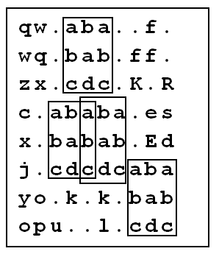

Restrictions. 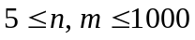; 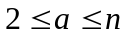; 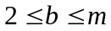 ; 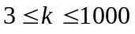.
The numbering of the rows and of the columns starts with 1 from the upper left corner.
CPU time should not exceed 1.5 seconds. You should not use more than 48 Megabytes of memory. Your source file should be named cipher.pas, cipher.c or cipher.cpp.
Scoring. Your solution will be run against 10 testcases, each worth 10 points. The points will be given according to the following rules:
- If you have found a wrong cipher, you get 0 (zero) points for the test.
- If you have found the right cipher, you score P points, where P is calculated like this:
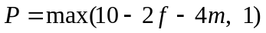,
where:
f is the number of false instances of cipher you have found.
m is the number of instances of the cipher which exist in the array, but have not been indicated in your file.
Saying it in other words, for every instance of cipher that you indicate to in your file that is wrong, you will lose 2 points. For every instance that contains the cipher, but is not indicated in your file, you will lose 4 points.
No instance, either correct or incorrect, of the cipher in the array should be indicated 2 or more times. If you write any position twice in the output file, you will score 0 (zero) points for that particular test.

